Frequency Response of BJT Amplifiers

All amplifiers typically exhibit a band-pass frequency response as in Figure 1. The cut-off frequency on the low end is usually determined by the coupling and bypass capacitors (if there are no such capacitors the low end extends all of the way to DC). The high frequency limit is typically determined by internal capacitances in the transistor itself.

Av0

f_{low1}
f_{low2}
f_{high}

Figure 1 – Frequency response of a typical amplifier.

Low frequency response

If an amplifier does not have coupling or bypass capacitors, then in general the low frequency response goes all of the way down to DC. However, as we discussed in class, it is desirable to have these capacitors in the circuit to isolate the amplifiers DC bias point from the outside world.

In the most general case (Figure 2), the input and output coupling capacitors lead to a high-pass filter response determined by the resistances they see:

R_{i}
C₂
C₁

V_{in}
R_{in}
R_{L}
R_{o}

Figure 2 – Two port model of a general amplifier.

In general, we can calculate their cutoff frequencies using the following formulas:

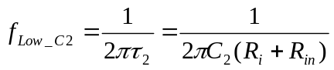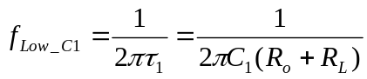

Where R_{i} is the source resistance, R_{L} is the load resistance, R_{in} is the input resistance for your amplifier and R_{o} is the output resistance for your amplifier. These last two are calculated based on the type of amplifier you are working with (See the handout on small signal amplifier calculations).
Once you have calculated the frequencies due to C₁ and C₂, the cutoff is determined by the following rules:

- If the two frequencies are more than a decade apart then f_{low2} in Figure 1 (the 3db point of the amp) is simply the higher of the two values.
- If the two frequencies are closer than one decade, then the actual cutoff frequency of the amp is somewhat larger than either of the two calculated frequencies.
- If the amplifier has a bypass capacitor, then it can also influence the cutoff frequency. Typical, emitter bypass capacitors are chosen large enough so that their effects are negligible.

High Frequency Response

As previously stated, the high frequency response of a discrete transistor amp is determined by the internal capacitances of the transistor itself (Figure 3).
C_{oB}

C_{be}

Figure 3 – High frequency model of a BJT

If either C_{be} or C_{oB} short out at high frequencies, then the transistor stops acting as an amplifier and so the response is cut off. The values of C_{be} and C_{oB} can be found or calculated from the transistor spec sheet. Typically, C_{oB} is on the spec sheet and C_{be} is calculated from f_{T} (the gain-bandwidth product) also found on the spec sheet using:
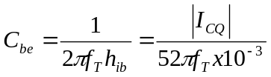

Once the capacitance values are known, the high frequency cutoff value can be calculated from the following formulas:

Common Emitter Amp

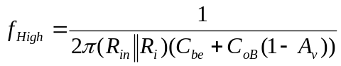

Common Collector Amp
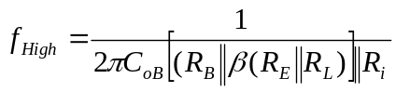

Common Base Amp

